|  |  |
| --- | --- |
| **Project Case** |  |
| COMP6583 | COMP6583001  Computer Graphics |
| **Computer Science** | **O262-COMP6583-OV01-00** |
| ***Valid on*** *Odd Semester Year 2025/2026* | **Revision 00** |

1. Kelompok tidak diperkenankan untuk:

*Members of the group are prohibited from:*

* + - Melihat sebagian atau seluruh jawaban kelompok lain,

*Seeing a part or the whole answer from other groups,*

* + - Menyadur sebagian atau seluruh jawaban dari buku, catatan, video, dan jenis referensi lainnya,

*Retell a part or the whole answer from books, notes, videos, and other references,*

* + - Menyadur sebagian atau seluruh jawaban dari internet,

*Retell a part or the whole answer from the internet,*

* + - Mengumpulkan jawaban yang tidak sesuai dengan tema soal,

*Submitting an answer with a different theme from the given case,*

* + - Melakukan tindakan yang menyebabkan jawaban dicontek oleh orang lain atau kelompok lain, baik disengaja maupun tidak disengaja,

*Doing action that could result the answer being copied by someone or other groups, intentionally or unintentionally,*

* + - Melakukan tindakan kecurangan lainnya.

*Committing other dishonest actions.*

1. Jika kelompok terbukti melakukan tindakan seperti yang dicantumkan pada butir ke-1, maka nilai mahasiswa dan/atau kelompok yang melakukan kecurangan, baik menyontek atau dicontek, akan dinolkan sesuai dengan peraturan yang berlaku.

*If it has been proven that a group has committed dishonest actions outlined in point 1 above, the whole groups related to the incident, regardless of which one copies or has their answer copied, will be issued a score of zero according to the regulation.*

1. Jawaban yang dapat diterima dan dinilai adalah jawaban yang dikumpulkan sebelum batas waktu yang telah ditentukan.

*The answer must be submitted before the designated deadline to be accepted and graded,*

1. Jawaban akan dinilai berdasarkan teknik atau metode yang diajarkan pada kelas praktikum dengan menggunakan software yang sudah ditentukan.

*The scoring will be based on the materials taught during the practicum classes using the designated software. Using different software than requested may result in your answer not being graded.*

1. Jika Anda tidak membaca peraturan ini, maka Anda dianggap sudah membaca dan menyetujuinya.

*By taking this exam, you agree to these regulations, regardless of whether you have read it or not.*

1. Persentase penilaian untuk matakuliah ini adalah sebagai berikut:

*The score will be distributed as follows:*

|  |  |  |
| --- | --- | --- |
| **Tugas Mandiri**  *Assignment* | **Proyek**  *Project* | **UAP**  *Final Exam* |
| 40% | 60% | - |

1. Perangkat lunak yang digunakan pada matakuliah ini adalah sebagai berikut:

*This course uses the following software:*

|  |
| --- |
| **Software**  *Software* |
| ThreeJS (r145)  Visual Studio Code  Web Browser (Google Chrome) |

1. Ekstensi file yang harus dikumpulkan untuk matakuliah ini adalah sebagai berikut:

*Your answers must be in the following file extensions:*

|  |  |  |
| --- | --- | --- |
| **Tugas Mandiri**  *Assignment* | **Proyek**  *Project* | **UAP**  *Final Exam* |
| HTML, CSS, JS, Asset Files | HTML, CSS, JS, GLB, Asset Files | - |

1. File yang harus dikumpulkan adalah keseluruhan jawaban beserta dengan aset yang digunakan (gambar, audio, video, dll) dan dokumentasi proyek yang berisikan link referensi aset dan penjelasan mengenai aplikasi yang dibuat (terlampir bersama dengan soal).

*Include other files that can support your project, such as: all files in your project, other files (image, audio, video, etc.) used in your project, *.doc file (documentation of your project) that contains all pages in your project, reference links of additional files (image, audio, video, etc.) used in your project, the description about how to use your application, etc.*

## Soal

*Case*

**OVerlord**

Ocat, an avid manga and light novel enthusiast, recently found himself immersed in a gripping tale set in a dark fantasy world. Captivated by its powerful characters and vivid storytelling, one scene struck him the most—a dramatic clash between a Dark Warrior and a giant, battle-hardened Hamster. Moved by the intensity of the moment, he set out to bring it to life through 3D graphics. As his friend and a three.js expert, you are asked to **design the scene using three.js library**.

1. **Project Structure**

Your project should contain a main html file, several JavaScript files, assets, and the three.js library. You are to acquire **three.js** either from the three.js [official website](https://threejs.org/), [github repository](https://github.com/mrdoob/three.js/), or [CDN link](https://cdnjs.com/libraries/three.js).

You are required to include the following piece of code in your html file.

|  |
| --- |
| <style>  * { margin: 0; padding: 0; }  body { height: 100vh; width: 100vw; overflow: hidden; }  </style>  <script src="[Path to index.js file]" type="module"></script> |

You are free to split your code into several different JavaScript file, but code the main logic for creating the scene inside “index.js” file.

1. **Scene**

Create a **full screen scene** that can be **dynamically resized** to fit the window. The scene also has **shadow map enabled** using **PCFShadowMap** as the shadow map type and **anti-aliasing** turned on.

1. **Camera**

Create cameras which details will be specified below.

* 1. **Third Person Camera**
     + This camera will have the following specifications:

|  |  |
| --- | --- |
| **Property** | **Value** |
| **Type** | Perspective Camera |
| **Field of View** | 75 |
| **Aspect Ratio** | Window Ratio |
| **Near** | 0.1 |
| **Far** | 1000 |
| **Position** | Vector3 (6, 3, 5) |

* + - This camera will focus on **Vector3 (0, 0, 0)** **position** and can be **rotated** around said position using **OrbitControls**.
  1. **First Person Camera**
     + This camera will have the following specifications:

|  |  |
| --- | --- |
| **Property** | **Value** |
| **Type** | Perspective Camera |
| **Field of View** | 75 |
| **Aspect Ratio** | Window Ratio |
| **Near** | 0.1 |
| **Far** | 1000 |
| **Position** | Vector3 (0, 1.8, 0) |

* + - This camera will focus on **Vector3 (1, 1.8, 0)** **position** and can be **rotated** around said position relative to the **Dark Warrior** model and **dynamically rotates** based on the model’s **orientation**.

1. **Light**

The scene is illuminated by **three** global lights, with **one** additional light dedicated to the spell effect

* 1. **Ambient Light (Global Light)**
     + Below are the specifications:

|  |  |
| --- | --- |
| **Property** | **Value** |
| **Intensity** | 0.7 |
| **Color** | #FFFFFF |

* 1. **Spot Light (Global Light)**
     + Below are the specifications:

|  |  |
| --- | --- |
| **Property** | **Value** |
| **Intensity** | 1.2 |
| **Color** | #FFFFFF |
| **Cast Shadow** | Yes |
| **Position** | Vector3(0, 10, 0) |
| **Distance** | 1000 |
| **Map Size Width** | 2048 |
| **Map Size Height** | 2048 |

* 1. **Directional Light (Global Light)**
     + Below are the specifications:

|  |  |
| --- | --- |
| **Property** | **Value** |
| **Intensity** | 0.5 |
| **Color** | #FFFFEE |
| **Position** | Vector3(5, 2, 8) |

* 1. **Point Light (Spell Effect)**
     + Below are the specifications:

|  |  |
| --- | --- |
| **Property** | **Value** |
| **Intensity** | 2 |
| **Color** | #FFD700 |
| **Position** | Vector3(0, 0.5, 0)  (x and z relative to Dark Warrior’s position) |
| **Distance** | 3 |

1. **Objects**
2. **Ground**
   * + Below are the specifications:

|  |  |
| --- | --- |
| **Property** | **Value** |
| **Geometry Type** | Box |
| **Width** | 25 |
| **Height** | 2 |
| **Depth** | 25 |
| **Material Type** | Mesh Standard Material |
| **Color** | #FFFFFF |
| **Position** | Vector3 (0, -1, 0) |
| **Receive Shadow** | Yes |
| **Texture Map** |  |

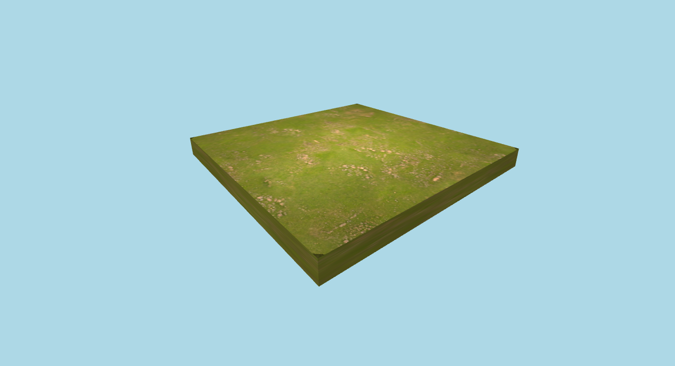

**Figure 1. Ground**

1. **Dark Warrior**
   * + The object will consist of **few parts**.
     + **Load** model from the **GLTF** file “**momonga_ainz_ooal_gown/scene.gltf**”.
     + The model supports basic movement and rotation:
2. Use **W/A/S/D** keys to **move** forward, left, backward, and right.
3. Use **Q/E** keys to **rotate** the model left and right.
   * + Below are the model’s specifications:

|  |  |
| --- | --- |
| **Property** | **Value** |
| **Cast Shadow** | Yes |
| **Receive Shadow** | Yes |
| **Position** | Vector3(0, -0.01, 3) |
| **Scale** | (0.01, 0.01, 0.01) |
| **Rotation** | (0, π / 2, 0) |
| **Movement Speed** | 0.1 |
| **Rotation Speed** | 0.05 |

* + - The model can **toggle a spell** using the **SPACE** key, which will summon or

remove a glowing magical spell circle beneath the Dark Warrior.

* + - Below are the spell circle’s specifications:

1. **Material Properties** (used by all spell components)

|  |  |
| --- | --- |
| **Property** | **Value** |
| **Material Type** | Mesh Phong Material |
| **Color** | #DAA520 |
| **Emissive Color** | #FFCC00 |
| **Emissive Intensity** | 2 |
| **Shininess** | 100 |
| **Transparency** | Yes |
| **Opacity** | 0.8 |
| **Side** | Double Side |

1. **Inner Ring**

|  |  |
| --- | --- |
| **Property** | **Value** |
| **Geometry Type** | Ring |
| **Inner Radius** | 1 |
| **Outer Radius** | 1.2 |
| **Theta Segments** | 64 |
| **Position** | (x, 0.02, z)  (x and z relative to model) |
| **Rotation** | (π / 2, 0, 0) |

1. **Outer Ring**

|  |  |
| --- | --- |
| **Property** | **Value** |
| **Geometry Type** | Ring |
| **Inner Radius** | 1.8 |
| **Outer Radius** | 2 |
| **Theta Segments** | 64 |
| **Position** | (x, 0.02, z)  (x and z relative to model) |
| **Rotation** | (π / 2, 0, 0) |

1. **Pointer 1 and Pointer 2**

|  |  |
| --- | --- |
| **Property** | **Value** |
| **Geometry Type** | Box |
| **Width** | 0.05 |
| **Height** | 4 |
| **Depth** | 0.01 |
| **Position** | Vector3 (0, 0.01, 0)  (x and z relative to model) |
| **Rotation** | (π / 2, 0, π / 2) |

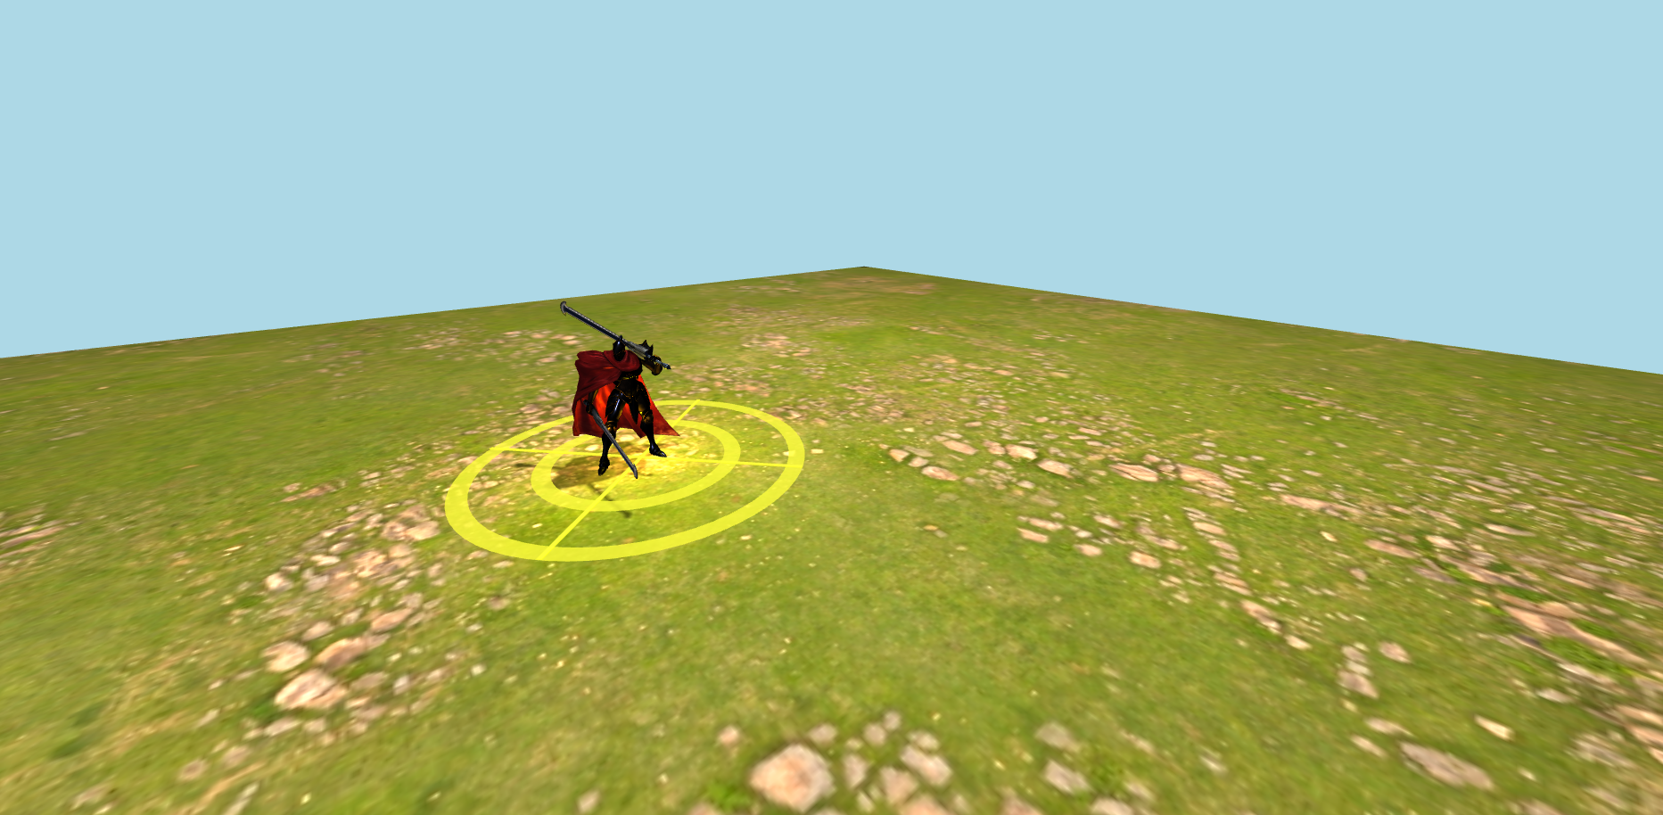

**Figure 2. Dark Warrior**

1. **Hamster**
   * + The object will consist of **a few parts**. Apply this property to each part of **Hamster**:

|  |  |
| --- | --- |
| **Property** | **Value** |
| **Material Type** | Mesh Phong Material |
| **Cast Shadow** | Yes |
| **Receive Shadow** | Yes |

* + - When the **hamster's body is clicked**, its **face will change**, toggling between **happy** and **sad expressions**, and vice versa by using **Raycast**.

1. **Body**

|  |  |
| --- | --- |
| **Property** | **Value** |
| **Geometry Type** | Box |
| **Width** | 2 |
| **Height** | 2 |
| **Depth** | 2 |
| **Color** | #FFFFFF |
| **Position** | Vector3 (3, 1, -1) |
| **Rotation** | (0, π / 8, 0) |
| **Texture Map** | Front (Happy)  A cartoon of a rabbit  AI-generated content may be incorrect.  Front (Sad)  A cartoon of a cat  AI-generated content may be incorrect.  Left & Right  A grey and white background  AI-generated content may be incorrect.  Top & Back  A grey and black striped object  AI-generated content may be incorrect. |

1. **Tail (Main)**

|  |  |
| --- | --- |
| **Property** | **Value** |
| **Geometry Type** | Box |
| **Width** | 0.6 |
| **Height** | 2.8 |
| **Depth** | 0.6 |
| **Color** | #023020 |
| **Position** | Vector3(2.6, 1.4, -2.25) |
| **Rotation** | (0, π / 8, 0) |

1. **Tail (Extension)**

|  |  |
| --- | --- |
| **Property** | **Value** |
| **Geometry Type** | Box |
| **Width** | 0.6 |
| **Height** | 0.6 |
| **Depth** | 1.4 |
| **Color** | #023020 |
| **Position** | Vector3(2.44, 2.8, -2.62) |
| **Rotation** | (0, π / 8, π / 2) |

1. **Left Ear**

|  |  |
| --- | --- |
| **Property** | **Value** |
| **Geometry Type** | Cone |
| **Radius** | 0.2 |
| **Height** | 0.7 |
| **Radial Segments** | 128 |
| **Color** | #023020 |
| **Position** | Vector3(4.05, 2.2, -0.6) |
| **Rotation** | (0, 0, -π / 8) |

1. **Right Ear**

|  |  |
| --- | --- |
| **Property** | **Value** |
| **Geometry Type** | Cone |
| **Radius** | 0.2 |
| **Height** | 0.7 |
| **Radial Segments** | 128 |
| **Color** | #6B6860 |
| **Position** | Vector3(2.5, 2.2, 0) |
| **Rotation** | (0, 0, -π / 8) |

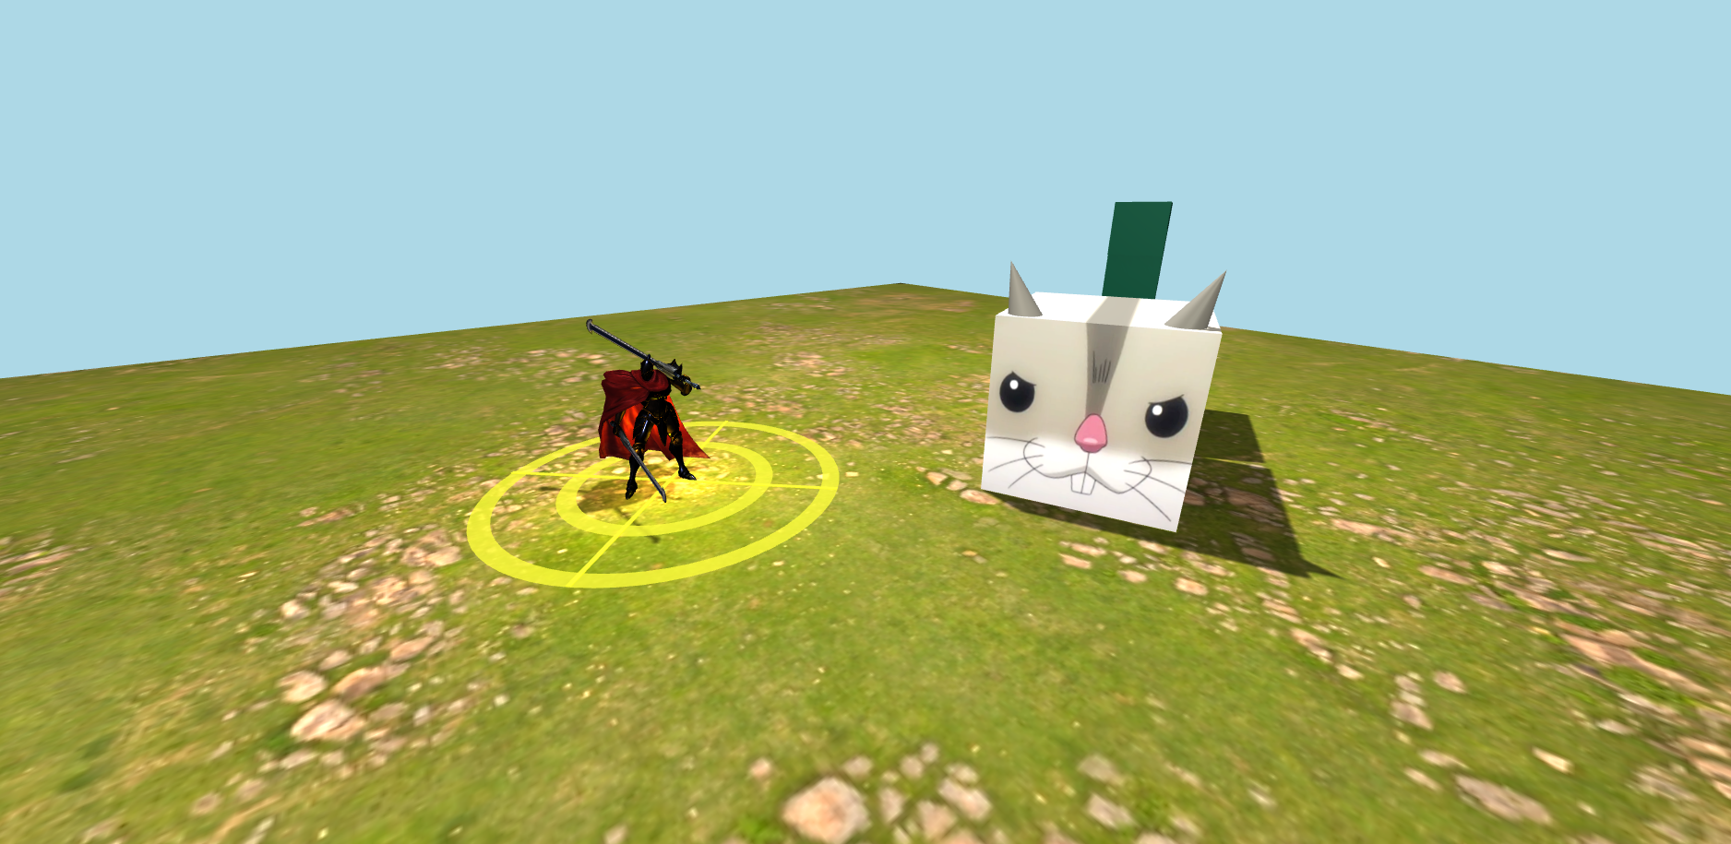

**Figure 3. Hamster**

1. **Tree**

There will be multiple instances of this object. The object will consist of **a few parts**. Apply this property to each part of **Tree**:

|  |  |
| --- | --- |
| **Property** | **Value** |
| **Material Type** | Mesh Standard Material |
| **Cast Shadow** | Yes |
| **Receive Shadow** | Yes |

1. **Trunk**

|  |  |
| --- | --- |
| **Property** | **Value** |
| **Geometry Type** | Cylinder |
| **Top Radius** | 0.6 |
| **Bottom Radius** | 0.6 |
| **Height** | 3 |
| **Color** | #FFFFFF |
| **Position** | Vector3(-5, 1.5, -5)  Vector3(7, 1.5, -6)  Vector3(-8, 1.5, 8) |
| **Texture Map** |  |

1. **Bottom Leaves**

|  |  |
| --- | --- |
| **Property** | **Value** |
| **Geometry Type** | Cone |
| **Radius** | 3 |
| **Height** | 4 |
| **Color** | #374F2F |
| **Position** | Vector3(-5, 4, -5)  Vector3(7, 4, -6)  Vector3(-8, 4, 8) |

1. **Top Leaves**

|  |  |
| --- | --- |
| **Property** | **Value** |
| **Geometry Type** | Cone |
| **Radius** | 2.1 |
| **Height** | 2.8 |
| **Color** | #374F2F |
| **Position** | Vector3(-5, 6, -5)  Vector3(7, 6, -6)  Vector3(-8, 6, 8) |

**Figure 4. Trees**

1. **Text**
   * + Below are the specifications:

|  |  |
| --- | --- |
| **Property** | **Value** |
| **String** | OVerlord |
| **Font Type** | Helvetiker Bold |
| **Size** | 1 |
| **Height** | 0.2 |
| **Depth** | 1 |
| **Material Type** | Mesh Standard Material |
| **Position** | Vector3 (-6, 4, 5) |
| **Rotation** | (0, π / 2, 0) |
| **Color** | #FFFFFF |
| **Cast Shadow** | Yes |
| **Receive Shadow** | Yes |

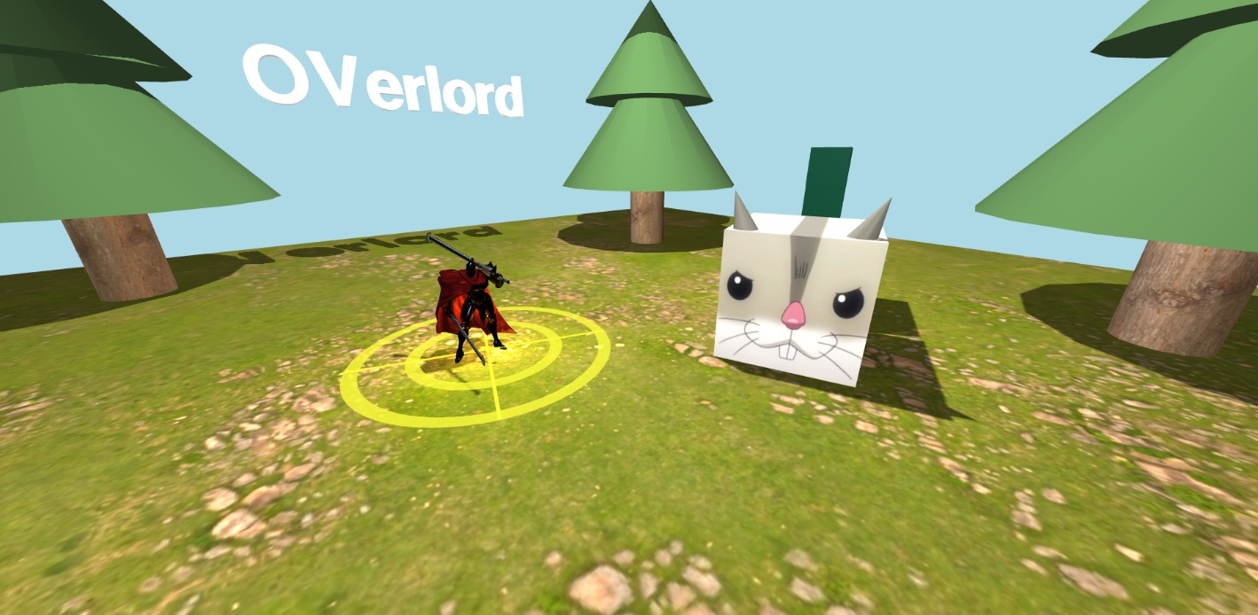

**Figure 5. Trees**

1. **Skybox**

Create the skybox using cube mapping technique.

|  |  |
| --- | --- |
| **Property** | **Value** |
| **Size** | 1200 x 1200 x 1200 |
| **Texture**  (In sequence: px, nx, py, ny, pz, nz) |  |

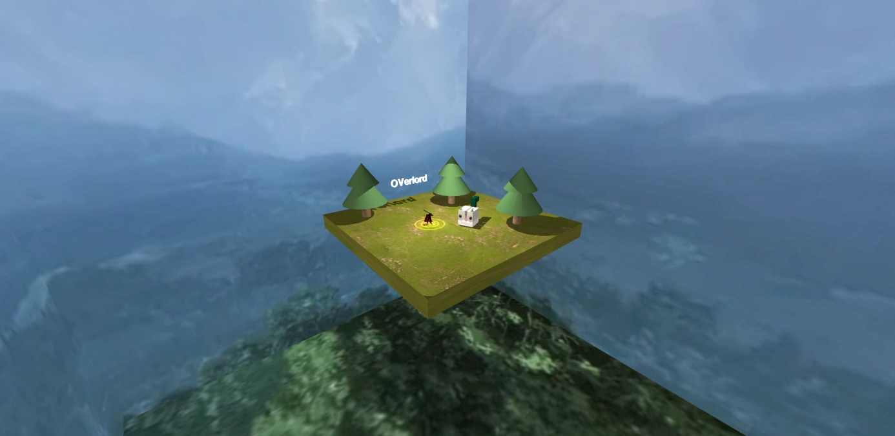

**Figure 6. Skybox**

**References:**

* <https://polyhaven.com/a/rocky_terrain_02>
* <https://sketchfab.com/3d-models/momonga-ainz-ooal-gown-baaa545c02ff47aa937665a40cdf5e72>
* <https://static.wikia.nocookie.net/overlordmaruyama/images/9/96/Overlord_Episode_07.png/revision/latest/scale-to-width-down/1000?cb=20150819004340>
* <https://static.wikia.nocookie.net/overlordmaruyama/images/9/9f/Overlord_EP07_086.png/revision/latest/scale-to-width-down/1000?cb=20150823115205>
* <https://polyhaven.com/a/chinese_cedar_bark>
* https://static.wikia.nocookie.net/overlordmaruyama/images/8/83/Great_Forest_of_Tob.png/revision/latest/scale-to-width-down/1000?cb=20150819132525